MILESTONE 2

Abstract
HearTone Analyzer is a user-friendly platform designed to accurately test and assess hearing abilities in patients of all ages. It automates the audiometry testing process, making it easier and faster to get results without needing much manual effort. The system performs air conduction tests at different frequencies, such as 250Hz, 500Hz, and up to 8000Hz, to determine how well a person can hear at various sound levels.
The platform uses advanced machine learning models, such as Support Vector Classifier (SVC) and Logistic Regression, to analyze the hearing data and predict the hearing condition of the patient. These models are trained on a large dataset, allowing the system to classify hearing impairments into different levels, from mild to severe.
After performing the tests, the system generates results that are easy to understand, helping doctors diagnose hearing problems accurately. The HearTone Analyzer is evaluated for its performance using accuracy, confusion matrices, and detailed reports to ensure it provides reliable results.
By automating the testing process, HearTone Analyzer helps audiologists get quick and precise results, reducing the chance of human error. This platform makes hearing tests more efficient and accessible, improving the way hearing loss is diagnosed and treated, ultimately leading to better outcomes for patients.

Literature surveys related to the HearTone Analyzer

- Data from: Pure-tone thresholds in adults aged 18 to 97 years and hearing aid use
This study in auditory health investigates pure-tone hearing thresholds among adults aged 18-97, focusing on hearing loss and hearing aid usage. It uses a comprehensive dataset of audiometric and self-reported data to identify age-based trends in hearing impairment and hearing aid adoption. The methodology includes audiometric assessments, with key performance metrics centered around hearing loss prevalence and adoption rates, offering insights into auditory health patterns across demographics.
Link- https://zenodo.org/records/4995261

- Hearing Tests Based on Biologically Calibrated Mobile Devices: Comparison With Pure-Tone Audiometry
Domain: Audiology, Mobile Health
Datasets: Clinical audiometry data and biologically calibrated mobile hearing test results.
Methodology: Comparative study between traditional pure-tone audiometry (PTA) and mobile-based hearing tests using biologically calibrated devices.
Performance Metrics: Sensitivity, specificity, and diagnostic accuracy of the mobile tests compared to PTA standards. The study assessed the usability and accuracy of the mobile approach for at-home or remote hearing assessments.
Link - https://mhealth.jmir.org/2018/1/e10/authors

- Artificial intelligence approaches for tinnitus diagnosis: leveraging high-frequency audiometry data for enhanced clinical predictions
This research explores the use of machine learning for tinnitus diagnosis using high-frequency audiometry data. It applied Logistic Regression (LR) and Artificial Neural Networks (ANN) to classify tinnitus presence. The study showed that the LR model, with an accuracy of 91.76% and AUC of 97.06%, significantly outperformed other classifiers. This approach offers a more objective and accurate method for tinnitus detection, surpassing traditional diagnostic methods that rely on subjective self-reporting​.
Link - https://www.frontiersin.org/journals/artificial-intelligence/articles/10.3389/frai.2024.1381455/full

- Toward Better Ear Disease Diagnosis: A Multi-Modal Multi-Fusion Model Using Endoscopic Images of the Tympanic Membrane and Pure-Tone Audiometry
This study develops a multi-modal, multi-fusion model combining endoscopic images of the tympanic membrane and pure-tone audiometry (PTA) data to diagnose ear diseases. Using deep learning, the model categorizes five disease states, including the novel "normal with hearing loss." Trained on 1,480 images and PTA data, the model achieved 92.9% accuracy and 90.9% recall, outperforming traditional methods. This approach significantly improves diagnostic performance and is robust across various datasets.
Link - https://ieeexplore.ieee.org/abstract/document/10286540

- Artificial Intelligence-Based Hearing Loss Detection Using Acoustic Threshold and Speech Perception Level
This study develops an AI-based model to detect hearing loss by integrating acoustic threshold and speech perception data. The dataset includes both standard audiometric measurements and speech comprehension results. The methodology uses machine learning algorithms to analyze these variables, aiming for accurate hearing loss detection. The model demonstrates high accuracy, offering a robust alternative to traditional diagnostic methods. The performance metrics indicate strong potential for clinical application in detecting hearing impairment.
Link - https://link.springer.com/article/10.1007/s13369-023-07927-1

- Efficiency of Artificial Intelligence Methods for Hearing Loss Type Classification: An Evaluation
This study evaluates AI methods for classifying hearing loss types (sensorineural, conductive, and mixed) using pure-tone audiometry data. It tests various models, including Logistic Regression, Support Vector Machines, and deep learning techniques (CNN, RNN, LSTM). The dataset comprises 4007 samples labeled by audiologists. The LSTM model achieved the highest accuracy at 97.56%. The paper also explores the impact of data augmentation via Conditional Generative Adversarial Networks and standardization on model performance.
Link - https://intapi.sciendo.com/pdf/10.14313/jamris/3-2024/19

- Automated Hearing Impairment Diagnosis Using Machine Learning: An Open-Source Software Development Undergraduate Research Project
This study focuses on the development of an open-source software tool for diagnosing hearing impairment using machine learning. The methodology involves the analysis of hearing test data through various algorithms to classify hearing loss types. The dataset includes clinical audiometry results. Performance metrics such as accuracy, precision, and recall are evaluated, with the system aiming to provide automated, efficient, and reliable support for hearing loss diagnosis
Link - https://onlinelibrary.wiley.com/doi/abs/10.1002/cae.22724

- Detecting Type of Hearing Loss with Different AI Classification Methods: A Performance Review
This study evaluates AI methods for classifying hearing loss types—sensorineural, conductive, and mixed—using pure tone audiometry data from 4007 audiograms. Various machine learning models, including Logistic Regression, SVM, Decision Trees, and RNNs, were assessed. RNNs achieved the highest accuracy at 94.46%, demonstrating strong potential for AI in early hearing loss detection. The paper emphasizes the efficiency of AI models in supporting audiologists, particularly in resource-constrained settings
Link - https://ieeexplore.ieee.org/abstract/document/10306088

- Automated Hearing Loss Type Classification Based on Pure Tone Audiometry Data
This study introduces a Bi-LSTM neural network for classifying hearing loss types (normal, conductive, mixed, and sensorineural) using pure tone audiometry data. Trained on 15,046 audiograms, the model achieved a 99.33% classification accuracy. The system aims to assist general practitioners in classifying audiometric results and provides audiologists with a decision support tool to improve diagnostic efficiency and reduce human error
Link - https://www.nature.com/articles/s41598-024-64310-2

Data Pre-Processing

1. Data Generation and Frequency Analysis
- Dataset Overview:
  - Used HoerstatAalen_HTLdata.csv containing HTL data for both ears at key frequencies (250 Hz to 8000 Hz).
  - Included the target variable HearAids indicating hearing aid usage.
- Correlation Calculation:
  - Computed the correlation between each HTL column and HearAids to determine the influence of each frequency.
  - Identified the most influential frequencies based on these correlations.
- Weight Assignment:
  - Calculated the weights by:
    - Taking the absolute value of each correlation.
    - Normalizing by dividing by the total sum of absolute correlations to get relative importance.
- Averaging Left and Right Ear Weights:
  - Averaged weights of corresponding frequencies from the left and right ears for a holistic impact measure.
- Visualization:
  - Applied spline interpolation to create a smooth curve connecting average weights.
  - Visualized changes in frequency importance from low to high frequencies.
2. Data Processing Features
- Handling Missing Values:
  - Used mean or median imputation based on the data distribution to fill missing values and keep the dataset complete.
- Normalization and Scaling:
  - Min-Max Scaling: Scaled HTL data to a range between 0 and 1 for uniform feature representation.
  - Standard Scaling: Applied where necessary to standardize features to a mean of 0 and standard deviation of 1.
- Encoding Categorical Variables:
  - Label Encoding for binary or ordinal categorical data.
  - One-Hot Encoding for categorical variables with more than two categories to avoid introducing ordinal relationships.
- Feature Engineering:
  - Created interactions between key frequencies with strong correlations to the target variable, allowing the model to capture complex relationships.
- Data Splitting:
  - Split the dataset into training (80%) and test (20%) sets to evaluate model performance on unseen data.
- Feature Selection:
  - Implemented Recursive Feature Elimination (RFE) to retain the most relevant HTL features and refine the dataset for impactful analysis.
- Data Augmentation:
  - Generated modified copies of existing data through small random perturbations to enhance model robustness and reduce overfitting.
- Data Balancing:
  - Addressed target variable imbalance with SMOTE (Synthetic Minority Over-sampling Technique), creating synthetic samples for the minority class to promote balanced training.

Data Visualization / EDA using Python Lib

Data Visualization and Exploratory Data Analysis (EDA) Report
Objective
The goal of this analysis is to explore the correlation between hearing threshold levels (HTL) at different frequencies and the usage of hearing aids. Through data visualization and statistical techniques, we aim to understand which frequencies have the most significant impact on hearing aid usage.
Libraries Used
The following Python libraries were employed in the analysis:
- pandas: Used for loading, manipulating, and analyzing data in tabular format.
- matplotlib.pyplot: Utilized for creating visualizations such as plots and charts.
- scipy.interpolate.make_interp_spline: Used for performing spline interpolation to create smooth curves from discrete data points.
- numpy: Employed for handling numerical data and performing mathematical operations.
Data Preparation
The dataset, HoerstatAalen_HTLdata.csv, contains hearing threshold levels (HTL) for different frequencies and a target variable HearAids, which indicates the usage of hearing aids. The data was loaded using pandas and preprocessed to select only relevant columns related to HTL frequencies, along with the target variable.
Correlation Analysis
To understand the relationship between hearing threshold levels at various frequencies and hearing aid usage, we calculated the correlations between each frequency’s HTL and the HearAids variable. Correlations were computed using pandas’ corr() function, and the correlation coefficients were normalized by their absolute values to determine the relative importance of each frequency in relation to hearing aid usage.
Weight Calculation
The normalized correlations were then used to calculate weights for each frequency. These weights reflect the strength of the relationship between each frequency’s HTL and hearing aid usage. The absolute values of the correlation coefficients were summed and normalized to obtain these weights, providing a proportional representation of the influence of each frequency.
Average Weights for Left and Right Frequencies
Since the dataset includes HTL data for both the left ear (denoted as L_) and right ear (denoted as R_), the average weight for each frequency was computed by averaging the weights for the corresponding left and right ear frequencies. This provided a combined measure of the importance of each frequency in relation to hearing aid usage.
Spline Interpolation
To visualize the relationship between frequency and average weight in a continuous and smooth manner, spline interpolation was performed on the average weights for each frequency. This technique created a smooth curve that accurately represented the relationship between the frequencies and the calculated weights. Interpolation was performed using scipy.interpolate.make_interp_spline to generate a smooth curve for easier visualization and interpretation.
Visualization
The smooth curve was plotted using matplotlib to depict how the average weight changes across different frequencies. The plot provides a clear visual representation of which frequencies are most influential in predicting hearing aid usage. The x-axis represents frequency in Hertz (Hz), while the y-axis shows the corresponding average weight, which indicates the strength of the relationship with hearing aid usage.
Key Insights
- The plot indicates which frequencies have a higher average weight, suggesting that these frequencies are more critical in determining whether hearing aids are required.
- By smoothing the data, we can better understand the trends and patterns, identifying frequencies that may require more attention in clinical settings for hearing aid prescriptions.
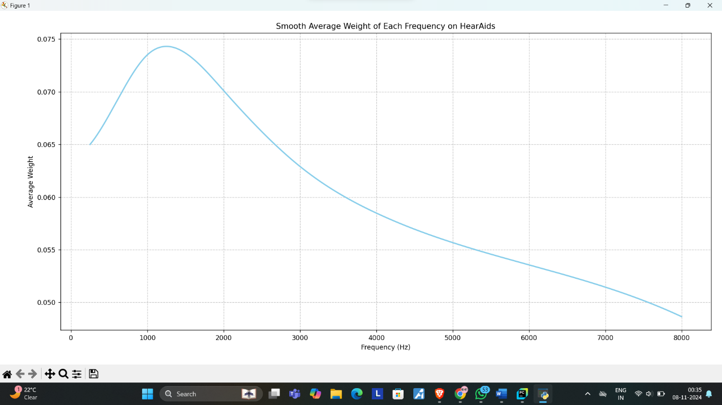
Model Creation and Testing
Model Creation
We created two models for predicting a person’s hearing condition based on their hearing thresholds at different frequencies:
- Support Vector Classifier (SVC)
- Logistic Regression
The process of model creation involved the following steps:
- Data Preparation:
  - We loaded the dataset containing hearing thresholds at various frequencies and the target variable (condition), which indicates the hearing condition.
  - The features (X) are the hearing thresholds for frequencies ranging from 250Hz to 8000Hz, and the target (y) is the condition.
- Data Splitting:
  - The dataset was divided into two sets: 75% of the data for training and 25% for testing, using the train_test_split function.
- Data Scaling:
  - The data was scaled using StandardScaler to standardize the features, ensuring that all frequencies are on a similar scale, which helps improve the model’s performance.
- Model Training:
  - Support Vector Classifier (SVC): We used the linear kernel for this model. The model was trained on the training set and tested on the test set.
  - Logistic Regression: This model was trained using the One-vs-Rest strategy for multi-class classification, and predictions were made for new and test data.
Model Testing
Both models were tested using the test dataset, and their performance was evaluated based on the following:
- Confusion Matrix:
  - It shows how many correct and incorrect predictions were made by the model.
- Classification Report:
  - This report provides precision, recall, and F1-score for each class, helping evaluate how well the model performs in distinguishing between conditions.
- Accuracy:
  - The overall accuracy, calculated as the percentage of correct predictions, was also computed for both models.
Advantages
- Support Vector Classifier (SVC):
  - SVC is effective in high-dimensional spaces, which is suitable for this dataset with many features (frequencies).
  - It can handle non-linear decision boundaries effectively with the right kernel, though we used a linear kernel here.
- Logistic Regression:
  - Logistic Regression is simple, easy to interpret, and works well for binary and multi-class classification tasks.
  - It provides probabilities for predictions, which can be helpful in making decisions beyond just classification.
Disadvantages
- Support Vector Classifier (SVC):
  - SVC can be computationally expensive, especially with a large dataset and complex kernels.
  - The model’s performance highly depends on the choice of kernel and hyperparameters.
- Logistic Regression:
  - Logistic Regression may not perform well with complex, non-linear relationships between features.
  - It may struggle with highly imbalanced classes or multi-class problems, though it can handle them using strategies like One-vs-Rest.
Accuracy
- SVC Accuracy: The accuracy score from the SVC model reflects how well it classifies the hearing condition based on the test data.
- Logistic Regression Accuracy: Similar to the SVC model, the Logistic Regression model's accuracy is measured using the test data to evaluate how often it correctly predicted the condition.
In both models, the higher the accuracy, the better the model is at predicting the correct condition for new data.

